Heating and Cooling Systems
Conduction:
Is the transfer of heat energy through a substance by particle collision. 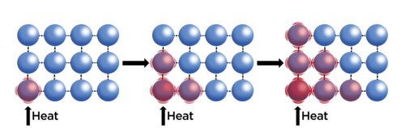
Thermal Conductivity:
Measures how much energy per second flows through 1 meter of a material per degree temperature difference between the two ends of the material.
-Unit is Wm⁻¹K⁻¹
- metals are good conductors

Convection:
Is the transfer of heat energy by bulk movements of particles.
-the flow of particles away from a warmer to cooler region produces convection currents.
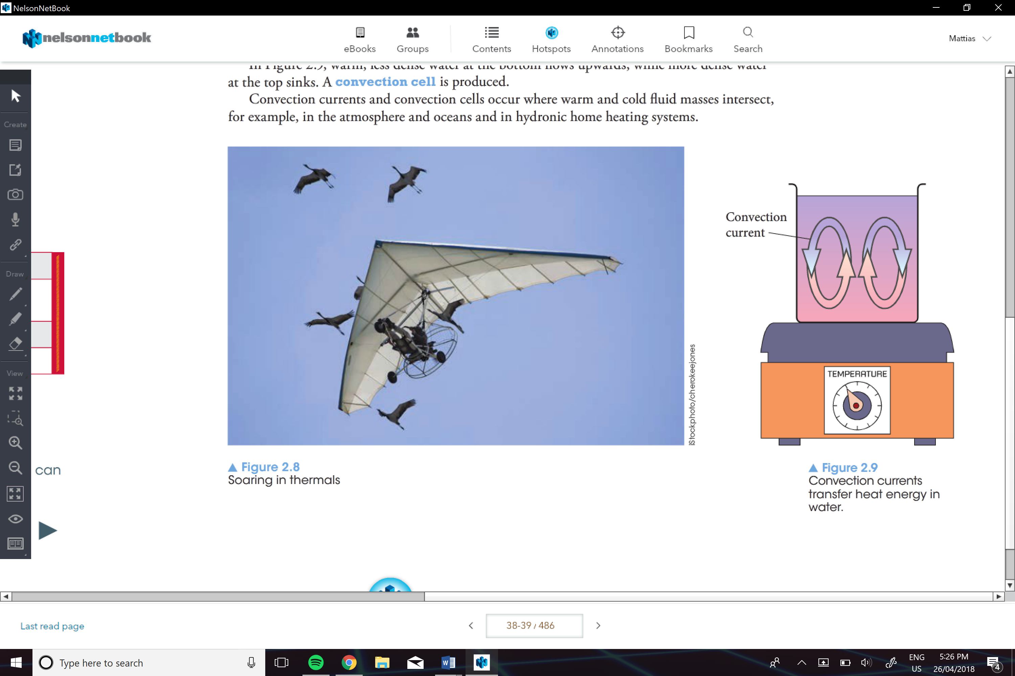
Radiation:
Is the transfer of energy that does not need a medium (through a vacuum).
Emissions and Absorption of Radiation by Surfaces:
-Black/ dark materials absorb more radiant heat
-White/light/ reflective surfaces reflect more radiant heat.

Black surfaces also radiate more heat too compared to white surfaces
Conservation of Energy in Open Systems
Isolated system:
Energy cannot be introduced into or emitted from.
-the only true isolated system is the universe
Closed System:
Is on that energy can enter or leave, but the amount of matter in the system remains constant.
Open System:
Can have both energy and matter moving across its boundaries
-e.g. the ocean

Energy Efficiency:
is the fraction of the input energy that produces a useful output
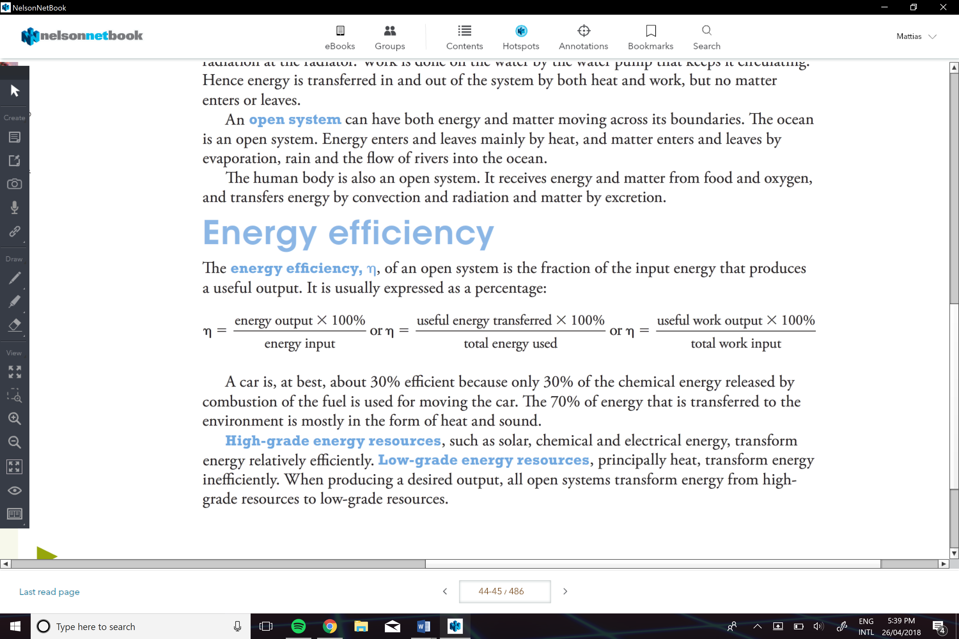

Passive Solar Design for Heating and Cooling of Buildings:
Ways to reduce heat gain or loss in houses:
- Using reflective foam
  - Will reflect and return radiation to the atmosphere
- Insulation batts with materials such as fiberglass or wool
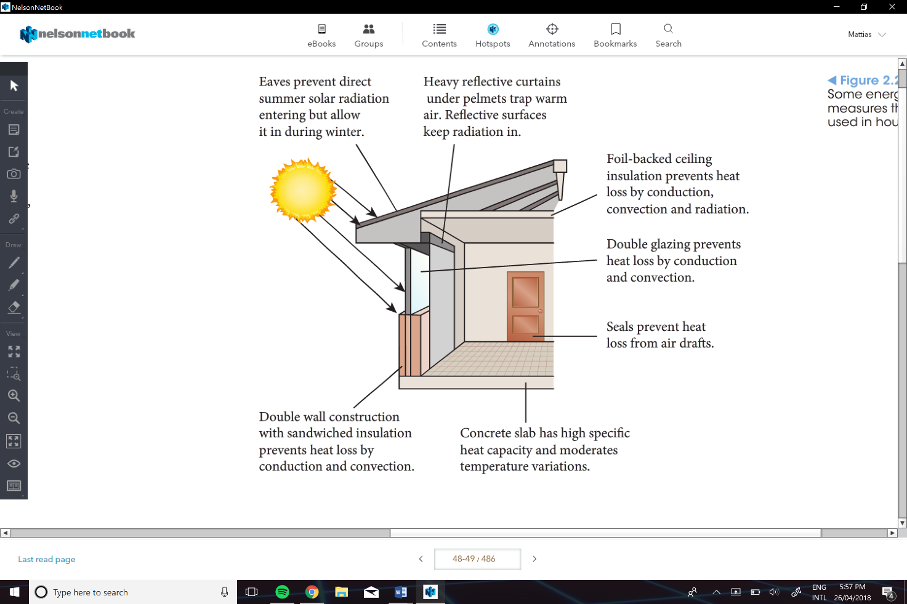
  - Have air trapped and makes it harder for heat to be transferred
Windows:
- Double glazed windows
  - Reduces heat transfer by convection and conduction
- Glazing
  - Helps reflect some of the radiation of the house
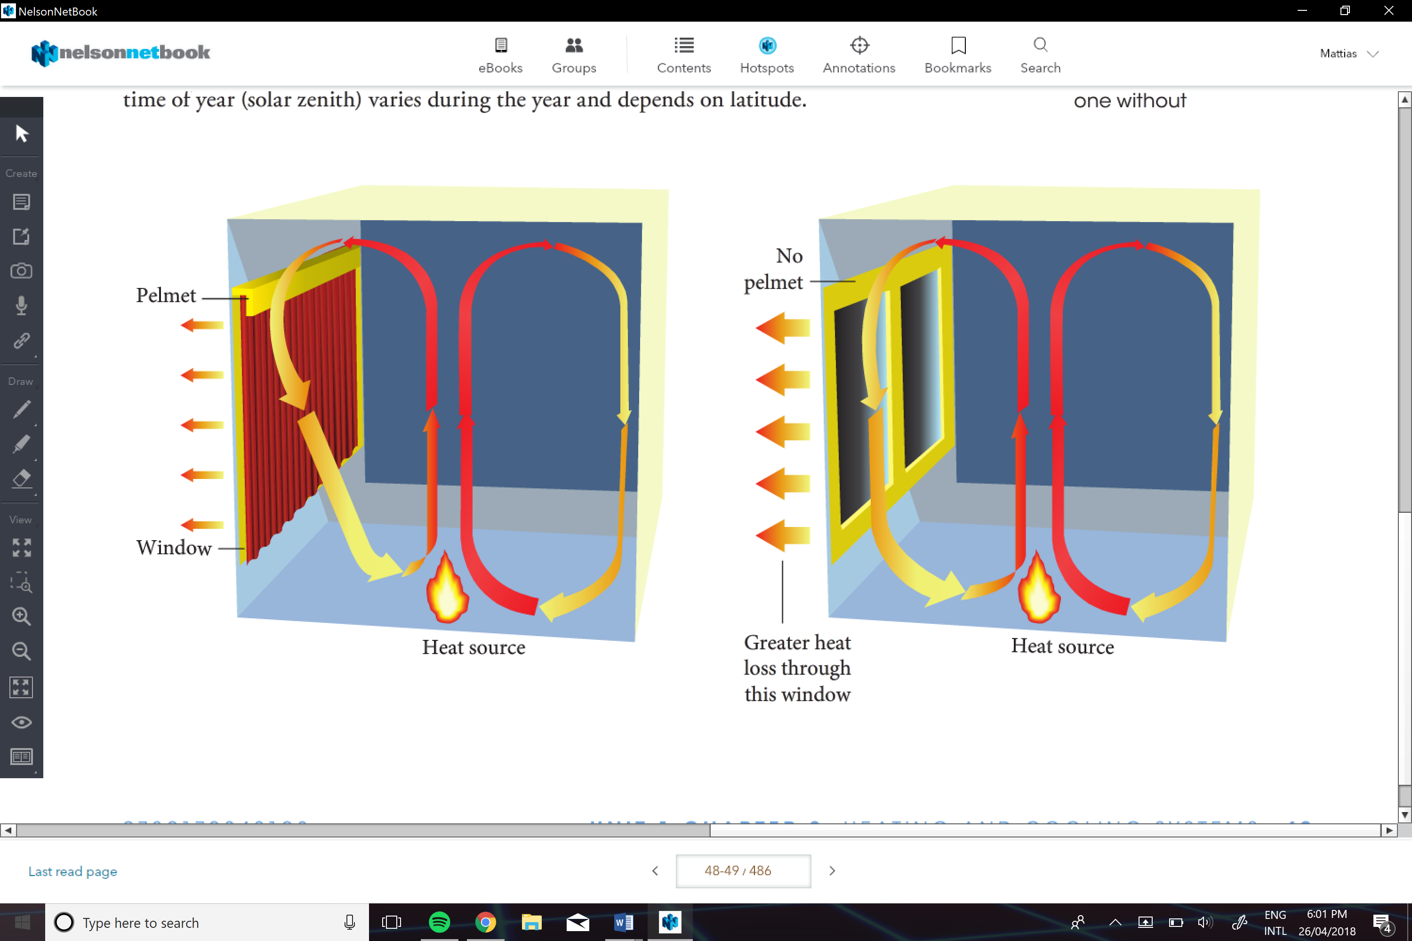
Heat Pump:
A system that moves heat energy from a cooler to a warmer area; work must be done on a heat pump.
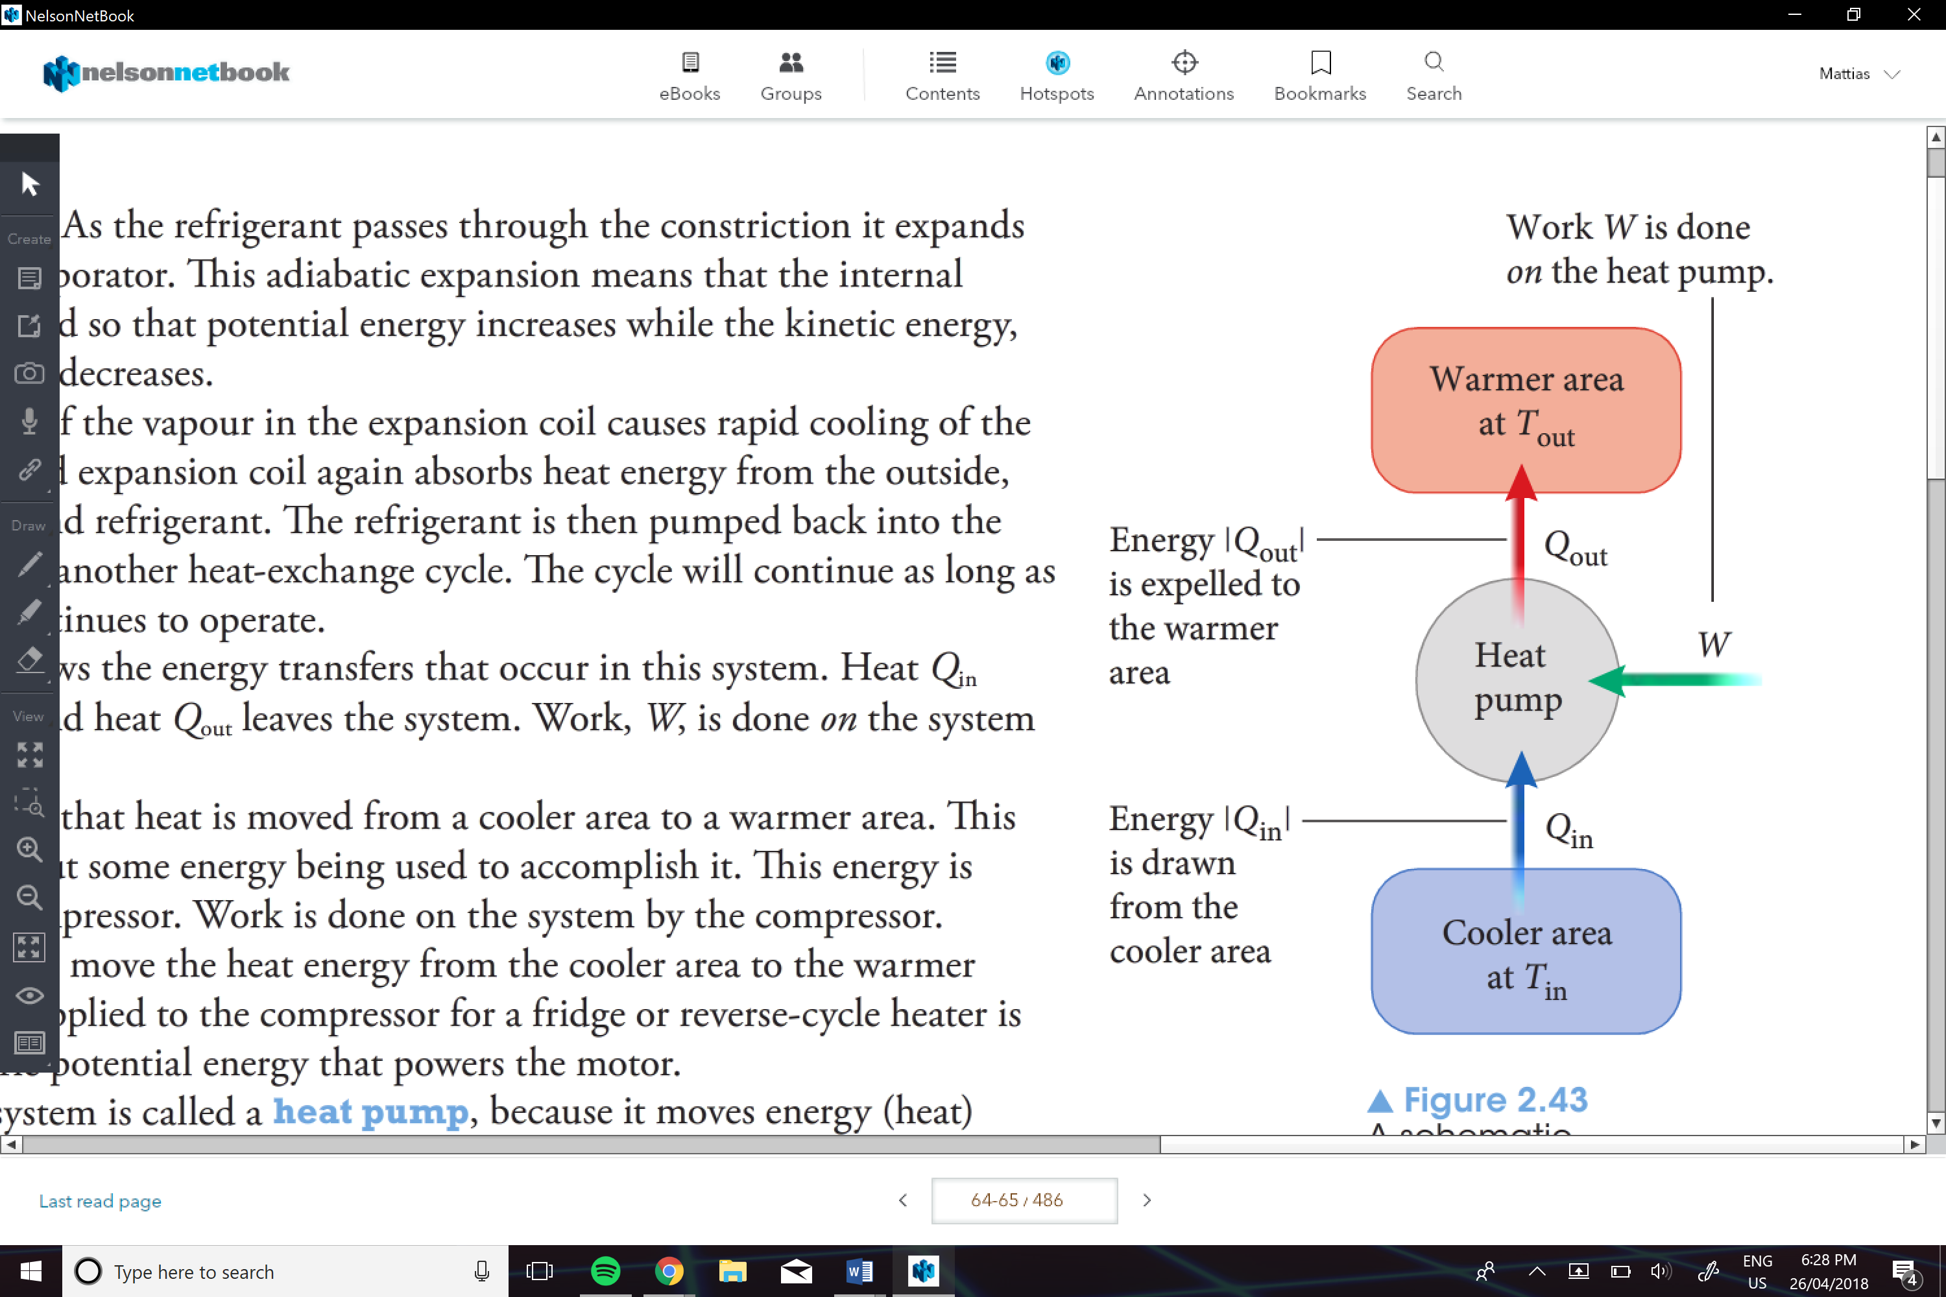

Refrigerator:
**The liquid refrigerant is constantly evaporated in the freezer coils
- The refrigerant absorbs heat from the content in the fridge
- Then the compressor condenses the gaseous refrigerant on the outside of the fridge
- The heat evolves id dissipated through metal cooling fins
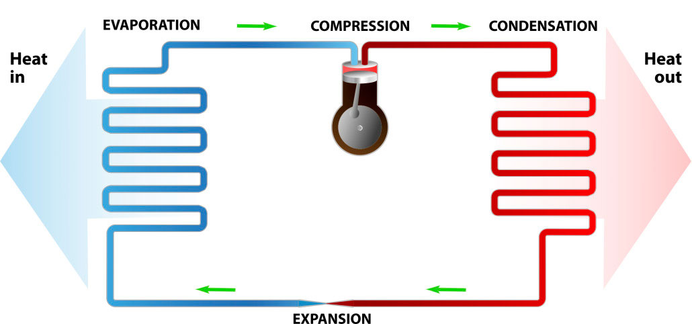

Solar Water Systems:
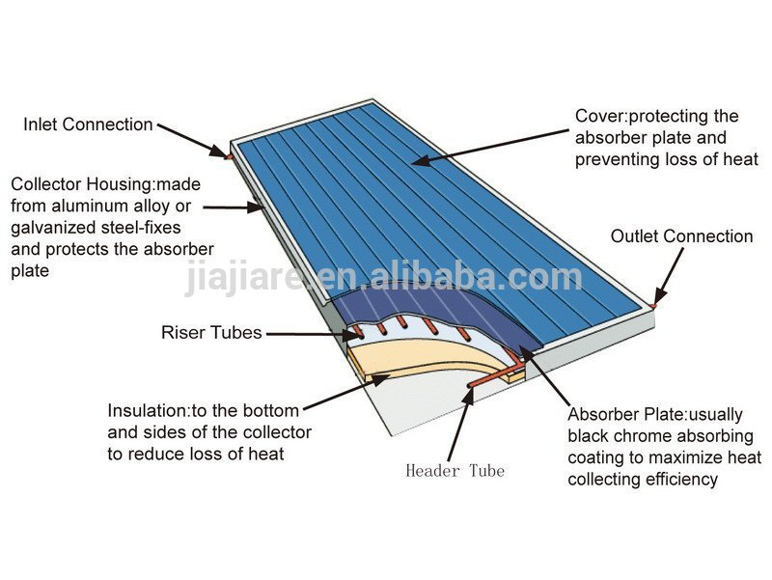
- Use copper/black tubing to absorb heat and conduct it to the water
- The inner side of the panel Is reflective to reflect the missed radiation
- The inner side of the glass is tempered so it also reflects any other radiation in the panel

Engine Cooling System in a Car:
A cooling system works by sending a liquid coolant through passages in the engine block and heads. As the coolant flows through these passages, it picks up heat from the engine. The heated fluid then makes its way through a rubber hose to the radiator in the front of the car. As it flows through the thin tubes in the radiator, the hot liquid is cooled by the air stream entering the engine compartment from the grill in front of the car. Once the fluid is cooled, it returns to the engine to absorb more heat. The water pump has the job of keeping the fluid moving through this system of plumbing and hidden passages.
